Methodology
This assignment builds off the previous one with the defining factor of time dependence. This is accounted for by using the backward Euler method:
$$\frac{∂ψ}{∂t}≈\frac{ψ^{n+1}-ψ^{n}}{Δt}$$
Thus
$$\frac{1}{v}\frac{∂ψ(x,μ,t)}{∂t}+μ\frac{∂ψ\left(x,μ,t\right)}{∂x}+Σ_{t}ψ\left(x,μ,t\right)=Q_{total}$$
$$⇒\frac{ψ(x,μ,n+1)-ψ(x,μ,n)}{vΔt}+μ\frac{d(x,μ,n+1)}{dx}+Σ_{t}=Q_{total}$$
With $Q_{total}$ being the total source term, including scattering, fission, external, and delayed (when applicable), and $n$ being the integer index for the current timestep. This allows us to easily discretize over space and angle.
$$\frac{ψ_{i,m,n+1}}{vΔt}+Σ_{t}ψ_{i,m,n+1}+\frac{\left|μ_{m}\right|}{Δx}ψ_{i,m,n+1}-\frac{\left|μ_{m}\right|}{Δx}ψ_{i-sgn\left(μ_{m}\right),m,n}=\frac{ψ_{i,m,n}}{vΔt}+Q_{i,n+1}$$
With $sgn(ξ)$ is the sign function, retuning -1 for negative number and +1 for positive numbers. This ensures the angular flux in some slab $i$ is informed by the flux over $μ>0$ from slab $i-1$ and by the flux over $μ<0$ from slab $i+1$. This can then be solved iteratively by taking an initial guess for flux at time $t=nΔt+Δt$, solving the above equation at every $μ_{m}>0$ from left to right, solving for every $μ_{m}<0$ from right to left, then comparing the solved flux to the initial guess (or previous solution) and reiterating until converged.
The value $Q_{total}$ is comprised of three or four terms depending on if delayed neutrons are considered.
$$Q_{total}=\frac{\left(Σ_{s}+\left(1-β\right)νΣ_{f}\right)}{2}ϕ+\frac{λC}{2}+q_{ext}$$
When delayed neutrons are not considered, the $λC$ and $β$ terms are 0. Otherwise,
$$\frac{∂C}{∂t}=βνΣ_{f}ϕ-λC$$
This is solved using the previous precursor concentration in
$$C_{guess}\left(t=nΔt+Δt\right)=\frac{C(t=nΔt)+ΔtβνΣ_{f}ϕ_{guess}}{1+λΔt}$$
And the source is solved in
$$Q_{guess}\left(t=nΔt+Δt\right)=\frac{Σ_{s}+\left(1-β\right)νΣ_{f}}{2}ϕ_{guess}+\frac{λC_{guess}}{2}$$
With an external source term included in the $ψ_{i-sgn(μ_{m})}$ term.

Questions
- Below is the scalar flux through 30 slabs as a function of time. Due to this being an S₂ code, the shapes of the flux profiles are not completely realistic. This shows the flux in the slab start at a 0 state and asymptotically approach a truncated cosine profile.
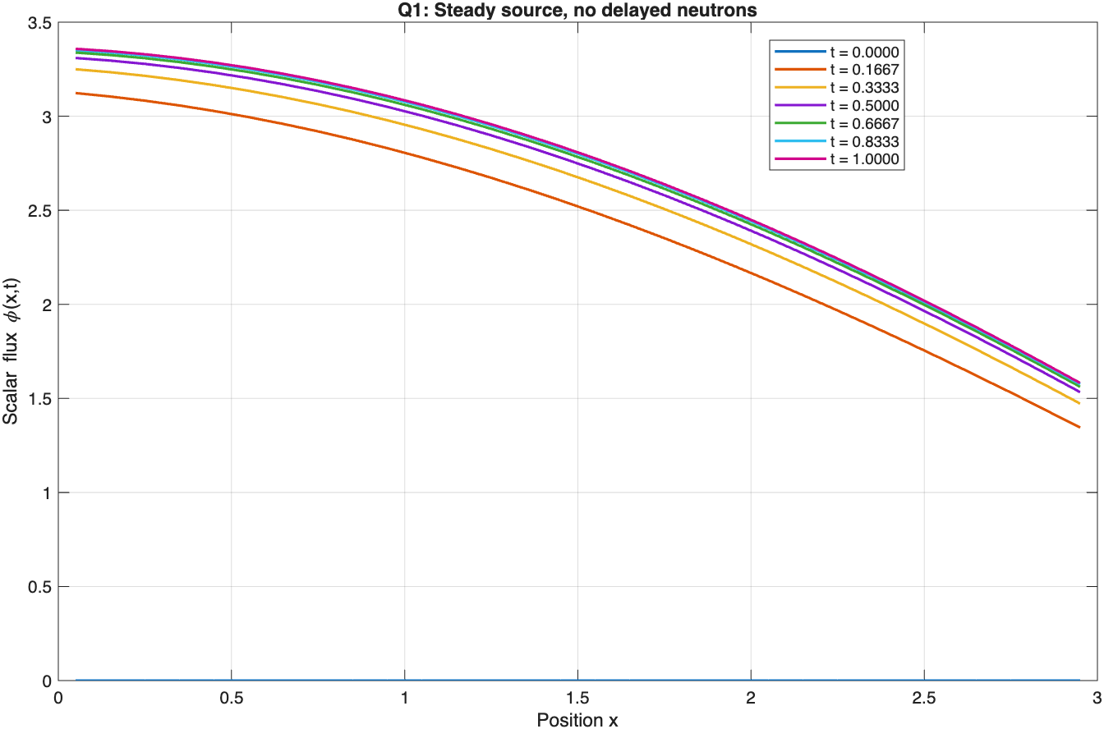
- When using a pulsed source, the flux reaches a cosine shape centered on the center of the media. As the slab thickness needed for a critical assembly is less than that needed multiply the source, the flux only has a very small magnitude.
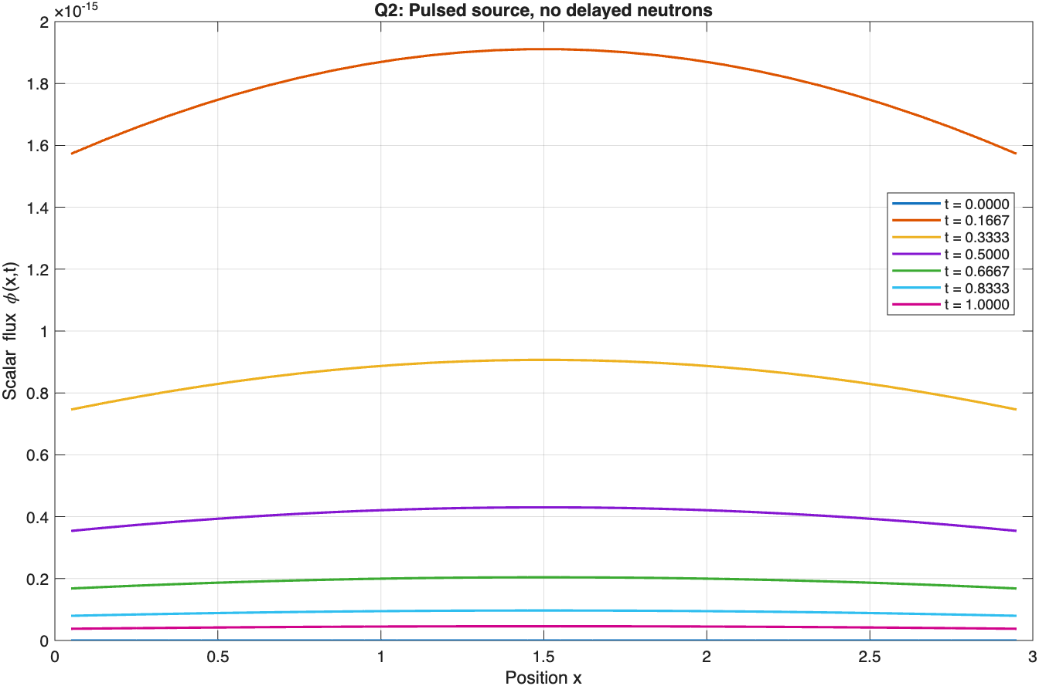
- The addition of delayed neutrons drastically lengthens the time it takes the flux to fully decay.
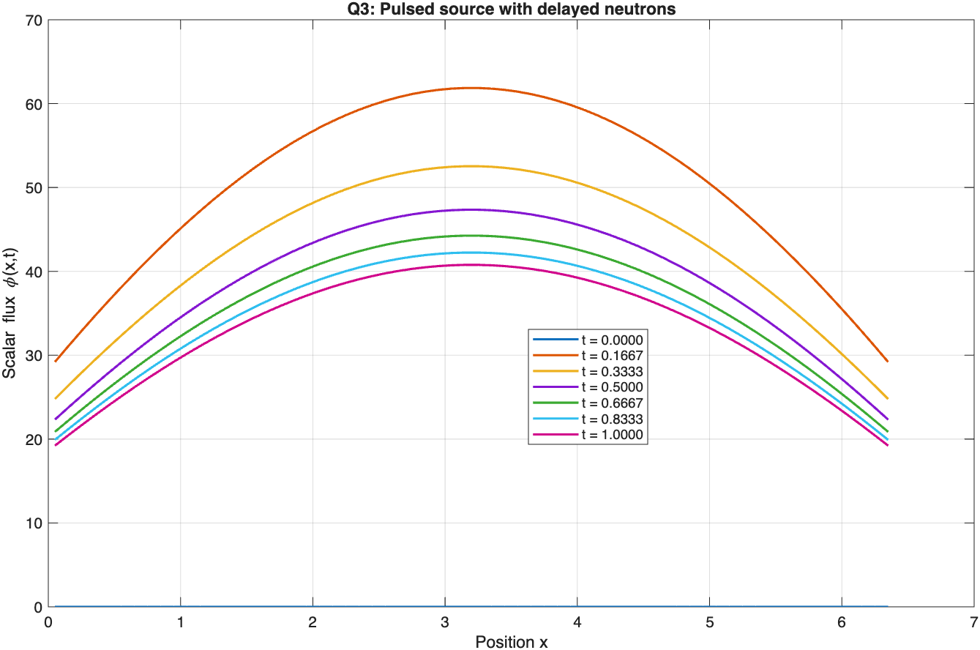
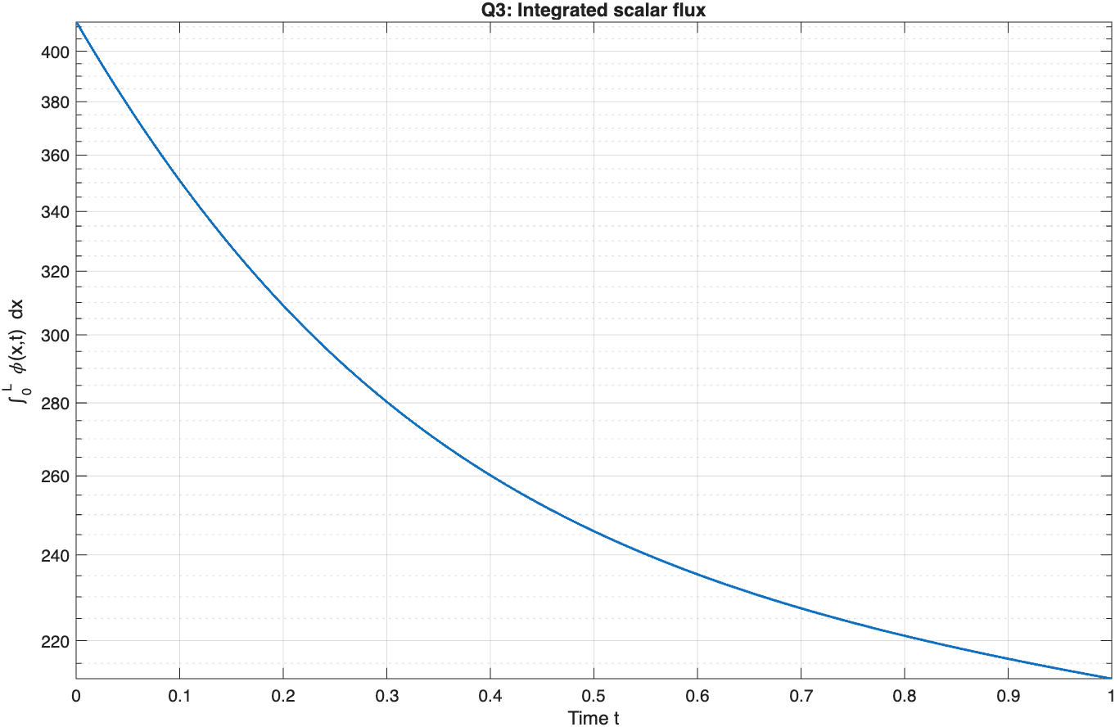
- With 65 slabs, the media is critical, but the higher delayed neutron fractions take longer to “see” that criticality.
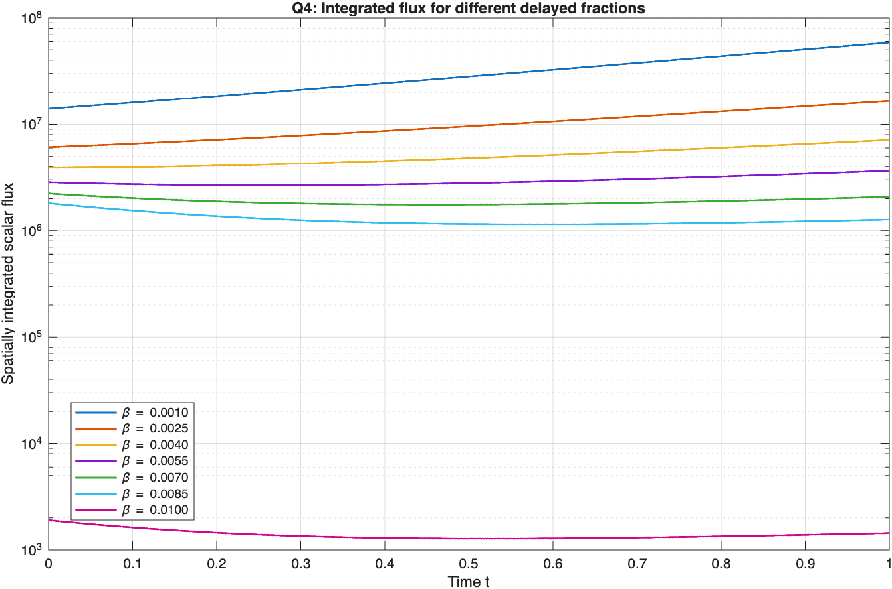
Code: https://github.com/TrevorTerrell/NE583HW3

